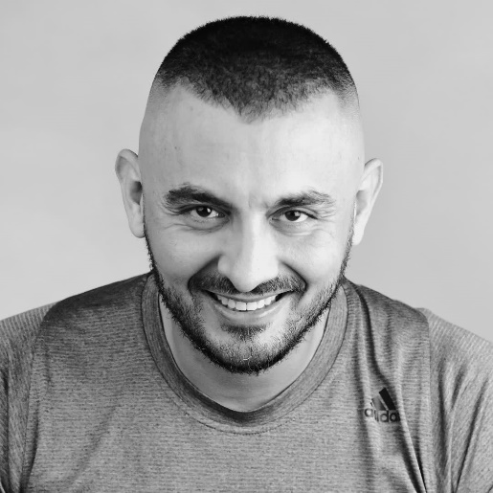 |  | nahd bashier  CEO of NB Oreem productions
Profile  • Name – Nahd Basheir  • ID-040083362  • Date of birth: 11.10.1980  • Profession - actor, director, screenwriter, and lecturer.  • Marital status - married.  Contact  Address  • Maghar - Zip Code - 20128 - PO Box 5772  • Mobile phone - 0544726084.  • Email - nahdtop@gmail.com  Workplace - CEO of NB oreem productions  Languages:  Arabic - mother tongue.  Hebrew - second language.  English - third language. |  | EDUCATION  • Bachelor's degree, B.A. Internship in acting and directing in the Department of Theater at the University of Haifa in 2007.  • Studies in theater teaching at the University of Haifa. 2008  • Group Instructors Course for Resolving National Conflicts. 2009  • M.A. Film Culture, University of Haifa. 2017  • Digital Advertising Studies. 2019  • Currently a law student at Rmat gan College.  WORK EXPERIENCE  • 2013-2018 Member of a High Committee in the Ministry of Culture and the Arts,  • 2014 Member of the Fringe Theater Committee at the Ministry of Culture.  • 2014 Member of the Druze and Circassian Culture Committee.  • Artistic director at the Kafron Theater since 2006- 2011  • Experience in professional theater and festivals: "The Wooden Captain" who participated in the 2009 Teatronetto competition. "Harvest" at the Acre Festival for another theater. "The Snow Kingdom" "Pain and Love", "The Last Field" it, as part of the Acre Festival 2007. "In the Acre Prison", as part of the Teatronetto 2007. "The Prisoner" as part of the Masarhid Festival 2007. "The Indian wants Acre".  At the Acre Festival in the play "The Impotents".. "The Illusion" as part of the 2004 Maserheid Festival in Acre. "The Last Tape of Krap" was a 2005 festival from Sarhid, and I won an award in the "Innovative Creation" category. I won two titles - Outstanding Actor - Best Play - at the Masarid Festival in Acre for the play "The Story of a Horse"

• Experience in directing-
I directed the TV series "Nakashat Ras" first season 2012, second season 2013.
"Bicycle Wings" Beit Hagefen Theater. 2010.
"Good morning animals" Capron Theater. 2010. "The Magic Bell" Beit Hagefen Theater. "Korkintos" Kafron Theater. "The Cockroach" "Child Forever" at the Masarid Festival, I won a commendation award. "The Servant of Two Masters" by Goldoni. "The Bear" 2007 "Objects" as part of the third mime festival. 2007 "Bloody Wedding" and more ..

Experience in film and television-
• 2018-2019 Leading role in the series Dr. Karaz1 / 2
• 2019 "Daughter of the Virgin". Hot.
• 2017 at Fauda 2.
• 2010 Blue Natalie.
• 2009 "Traffic Light 2" on Channel 2
• 2009 I starred in the movie, "Peek".
• 2009 "Island 2", Children's Channel.
• 2008 I starred in the film "PINK SUBARO" a joint production between Japan, Italy and Israel.
• 2007 "Restless" directed by Amos Kollek.
• 2006 I participated in the film "Adam and Eve" directed by Robert Kemar.

Experience in writing and translating:
• 2018 I wrote the second season of the series Dr. Crash.
• 2017 I wrote the series Dr. Crash.
• In 2016 I wrote the script "Blood Ties". "Image film for the Intelligence Corps Museum."
• 2015 I wrote the script "Depression". "Authority for the War on Drugs and Alcohol"
• 2015 I wrote the script "Sewing".
• In 2013 I wrote the play "Bag Journey".
• 2012 I wrote the play "Manipulation"
• 2011 I wrote a slap series called "Nakashat Ras".
• 2010 I wrote the play "Bicycle Wings" produced by the Beit Hagefon Theater.
• 2010 I wrote a movie script "Hands".
• 2009 I wrote the play "Corquintus" Kafron Theater.
• 2009 I wrote the play "Dangerous Game" Kapron Theater.
• 2009 I translated and did an adaptation of the play "Barefoot in the Episode" by Neil Simon, Almeidan Theater.
• 2009 I translated and did an adaptation of the play "A Midsummer Night's Dream" Shakespeare, Beit Hagefen Theater.
• 2009 I wrote the play "War Games"
• 2009 I wrote the play "Flashbike".
• 2008 I wrote the play "The Kingdom of the Ants" .. Allusion to children.
• 2008 I wrote the play "Dark Red" a play that deals with road safety.
• In 2008 I wrote the play "Forever a Child". Admitted to the 2008 Masarhid Festival.
• In 2008 I wrote the play "Women's Harvest". Acre Festival of Israeli Theater after 2008. Winning two awards. The best game, the best music.
• 2008 I wrote the play "King Shlomo is horny or immersed in a novel ?!".
• 2008 I translated into Hebrew the play "Love and Pain" by Sameh Khazazi.

• 2007 I wrote the play "The Last Field". Who participated in the Acre Festival 2007. The play has been translated into five languages.
• 2007 Translation and adaptation of S. "The Prisoner". Be careful with Arabic.
• 2007 I wrote the play "The Ballad Chicken Rebellion" 2008 participated in a short theater festival for social change 2008. and won first prize.
• 2006 Processing and translation of Tolstoy's 'Horse Story' into Arabic and Hebrew.
• 2005 I wrote the "Cockroach" play for children.
• 2005 I translated Becht's "The Last Tape of Krap" into Arabic.

Additional talents:
Plays and composes in several musical instruments. Guitar, oud, flute, bouzouki. Percussions.

